Supply Chain Report – Toyota RAV4 Braking System

# Executive Summary

The Toyota RAV4 braking system comprises six components—brake caliper, disc, pad, fluid, accessories, and caliper parts—with a combined cost of £458.58 excluding VAT and £550.30 including UK 20% VAT. Sourcing spans five countries, led by Germany (19 articles), Denmark (17), and the Netherlands (17). Tariff-shock simulations applying 10%, 30%, and 60% UK import duties on Japanese parts reveal minimal total cost increases—0.4%, 1.0%, and 1.3%, respectively. Recent US–Japan auto tariff developments underscore potential geopolitical spill-over risks. Alternative supplier analysis identifies credible sources in China, the United States, South Korea, Mexico, and Italy to reduce reliance on any single region. Recommendations focus on geographic diversification, duty relief mechanisms, real-time tariff monitoring, and contractual safeguards to enhance supply chain resilience.

# Key Points

* Vehicle/component: Toyota RAV4 braking system
* Combined price: £458.58 excl. VAT; £550.30 incl. 20% VAT
* Tariff scenarios tested: 10%, 30%, and 60% UK tariffs on parts from Japan
* High-level impact: cost increase of 0.4% (10%), 1.0% (30%), and 1.3% (60%)

# Component Analysis

The Toyota RAV4 braking system comprises six distinct components—brake caliper, disc, pad, fluid, accessories/parts, and caliper parts—with a combined cost of £458.58 excluding VAT and £550.30 including 20% UK VAT. All six parts are taxable under UK rules. The brake caliper is the highest-value line item at £240.64, representing 52.48% of total system cost, followed by the brake disc at £130.76 (28.51%) and the brake pad at £47.02 (10.25%). Geographic analysis shows a heavy European concentration: Germany supplies 19 articles, Denmark 17, and the Netherlands 17 of the 83 total articles. The United Kingdom and Italy contribute 10 and 7 articles respectively, highlighting regional sourcing exposure within Europe.

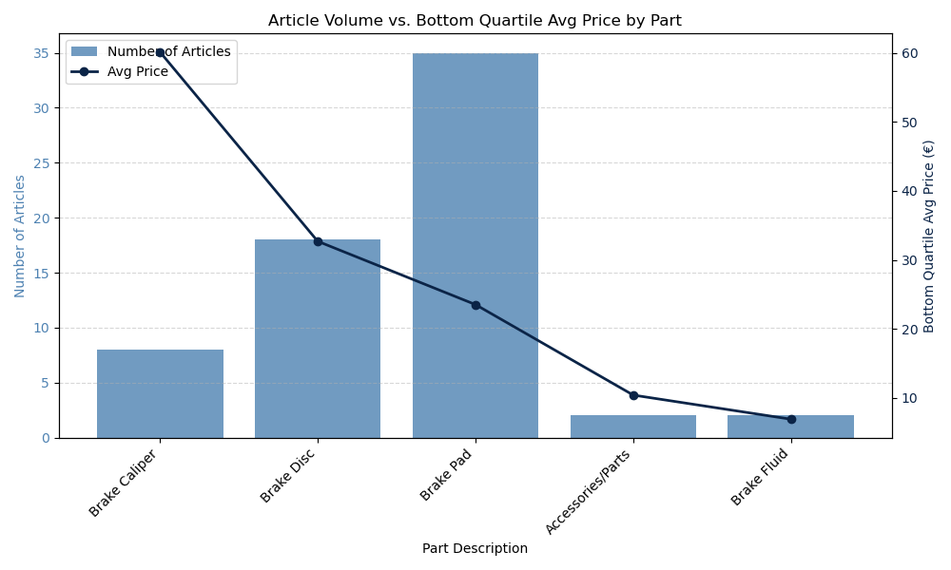

Figure: CA_combination_chart_articles_count_and_bottom_quartile_avg_price_per_part

CA_combination_chart_articles_count_and_bottom_quartile_avg_price_per_part

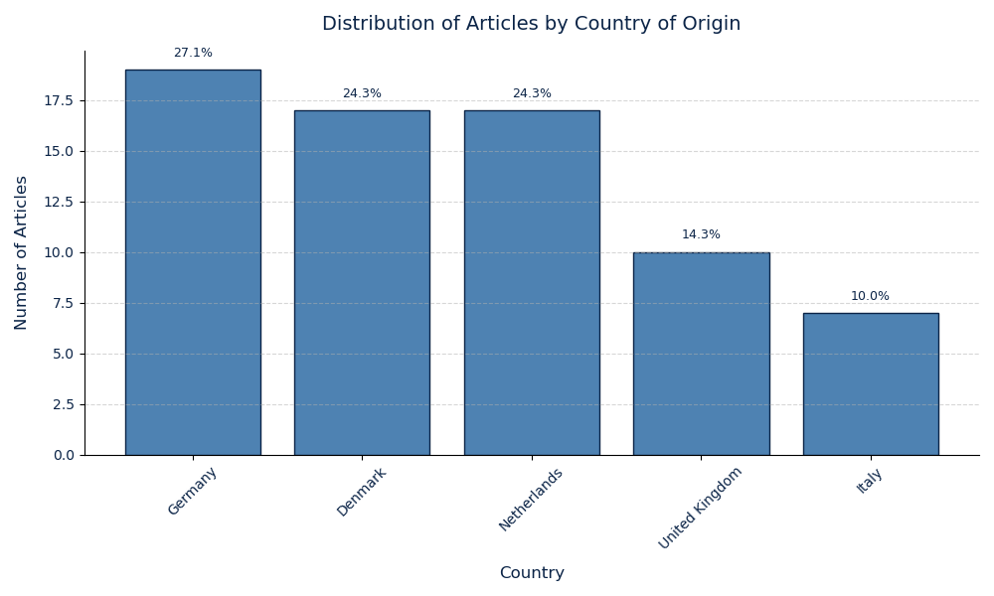

Figure: CA_bar_chart_articles_distribution_by_country_of_origin

CA_bar_chart_articles_distribution_by_country_of_origin

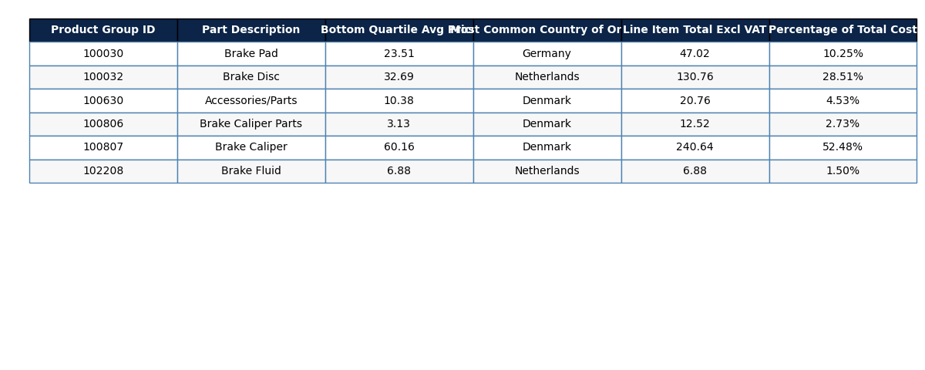

Figure: CA_table_summary_of_parts

CA_table_summary_of_parts

* Top 3 parts by cost share: Brake Caliper (£240.64, 52.48%), Brake Disc (£130.76, 28.51%), Brake Pad (£47.02, 10.25%)
* Top 3 suppliers by article count: DELPHI (10 articles), A.B.S. (10 articles), KAVO PARTS (5 articles)

# Tariff Simulation

Tariff-shock simulations evaluate the impact of hypothetical UK import duties on Japanese-sourced braking components under three duty rates: 10%, 30%, and 60%. The base scenario reflects the existing average tariff of 1.25% on Japanese auto parts, generating a base cost of £458.59, a tariff charge of £5.73, and VAT of £92.86, for a total pre-shock cost of £557.18. Under a 10% duty, final cost rises to £559.31, a £2.13 increase (0.4%). A 30% tariff pushes costs to £562.97, up £5.79 (1.0%), while a 60% rate results in £564.42, a £7.23 increase (1.3%). Because Japanese components account for only six of 83 articles, these shocks have limited effect on overall supplier competitiveness.

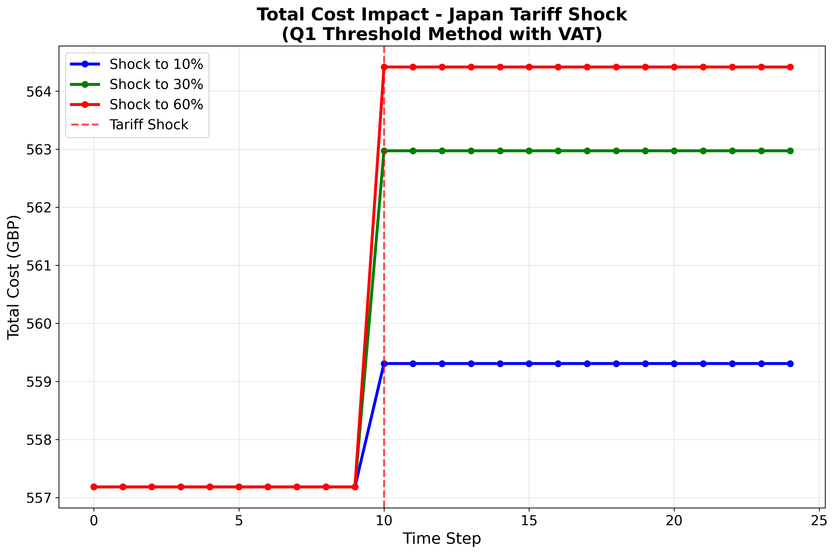

Figure: cost_progression_q1_method_japan_20250930_155734

cost_progression_q1_method_japan_20250930_155734

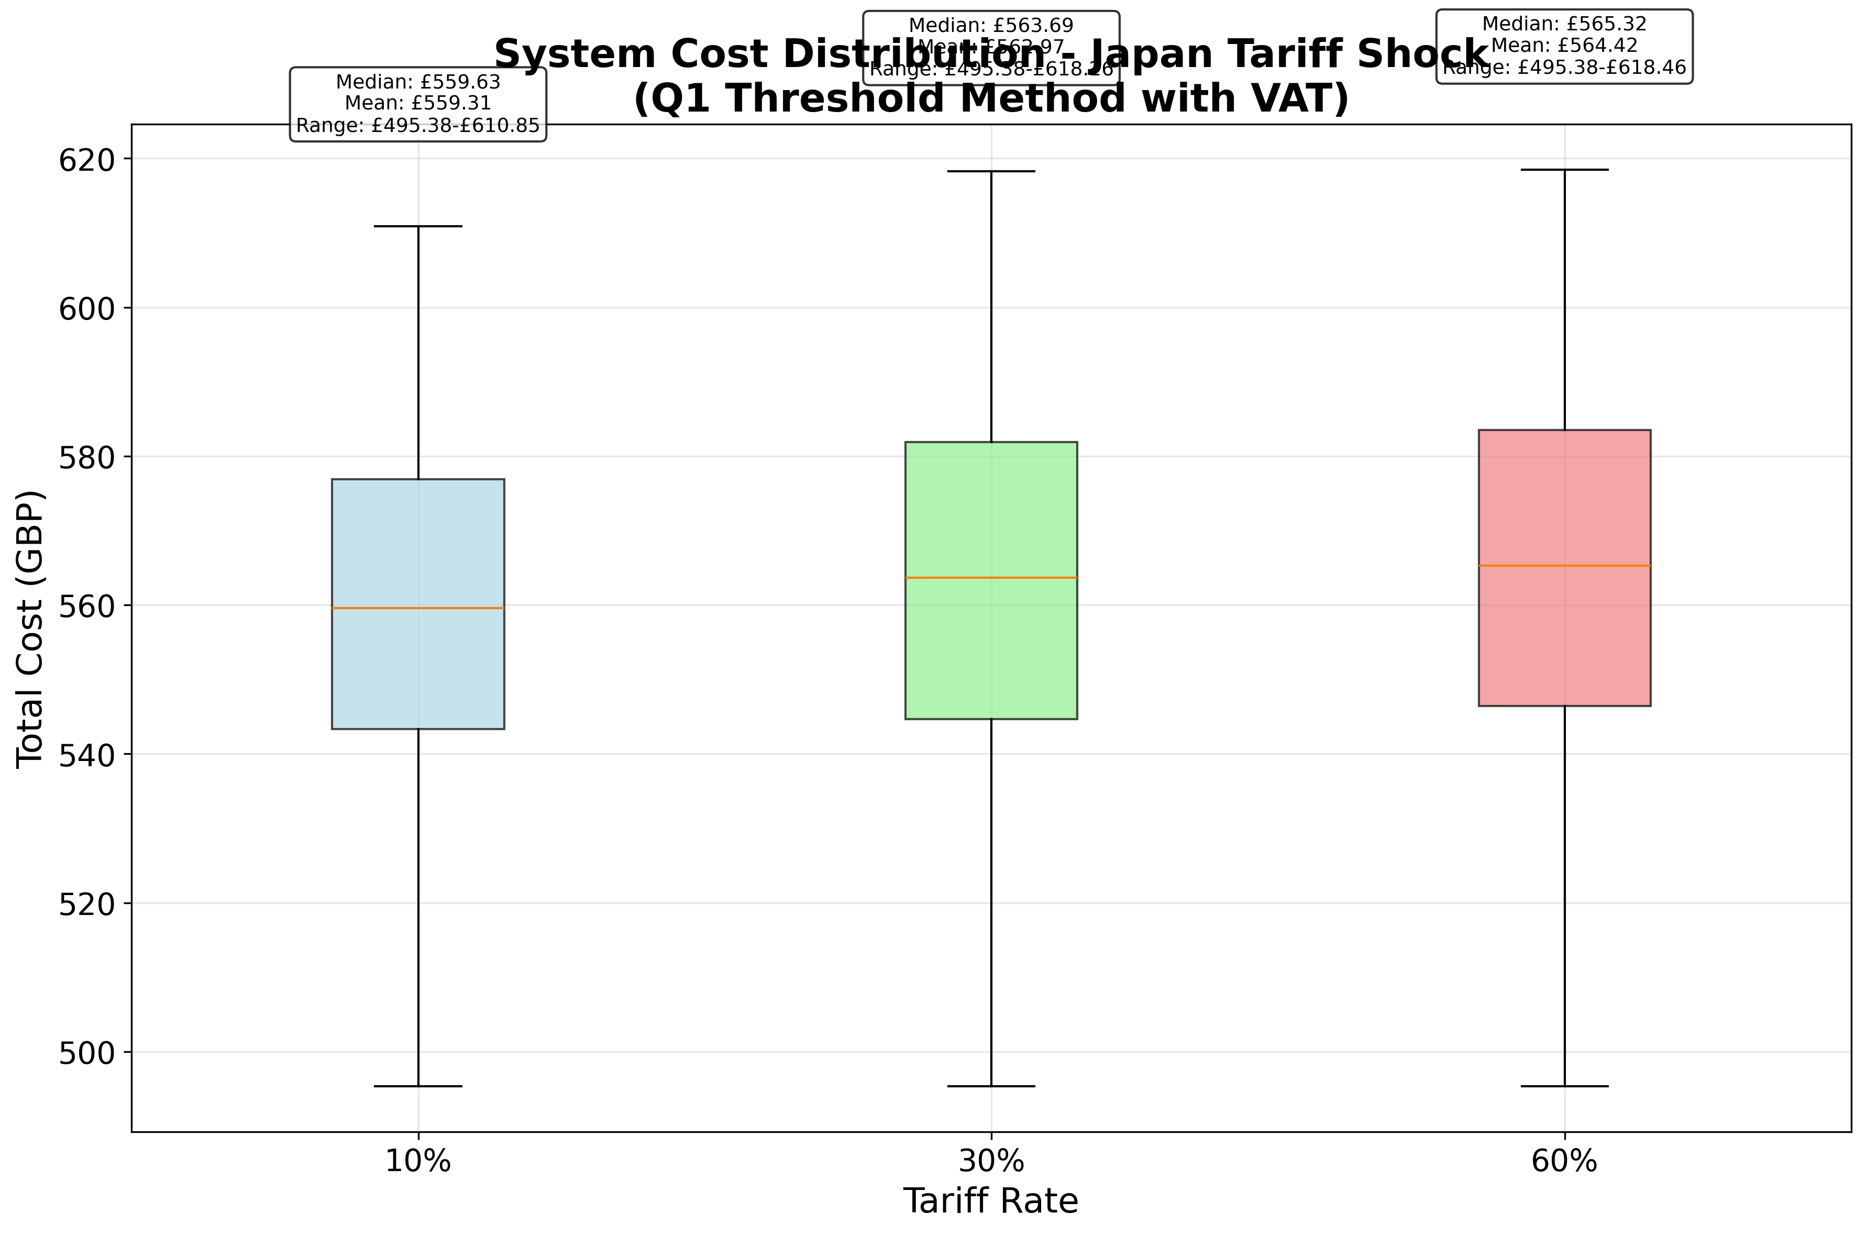

Figure: system_cost_distribution_q1_method_japan_20250930_155734

system_cost_distribution_q1_method_japan_20250930_155734

* Pre-shock cost breakdown: Base Cost £458.59; Tariff Cost £5.73; VAT Cost £92.86; Total Cost £557.18
* 10% tariff: initial £557.18 → final £559.31; increase £2.13 (0.4%)
* 30% tariff: initial £557.18 → final £562.97; increase £5.79 (1.0%)
* 60% tariff: initial £557.18 → final £564.42; increase £7.23 (1.3%)

# Tariff News

Recent developments in US–Japan trade have influenced industry sentiment toward potential UK policy shifts. In early September 2025, the US administration signed an order to implement reduced US tariffs on Japanese automobile imports, cutting rates from 27.5% to 15% within days of publication [1]. Concurrently, the US Commerce Department is considering additional national security tariffs on auto parts under Section 232, which could extend duties on imported components [2]. While these measures do not directly alter UK–Japan duties under the Comprehensive Economic Partnership Agreement (CEPA), they underscore ongoing geopolitical risks and may inform stakeholder expectations around future UK tariff reviews.

# Alternative Suppliers

Deep supplier analysis identifies credible alternatives to Japanese braking components across multiple regions. Chinese OEMs like **FrenoBrake** offer IATF 16949/ISO 9001/ECE R90-certified brake pads, discs, and calipers at competitive MOQs and 30–60 day lead times [3]. In the **United States**, **Dynamic Friction Company** supplies OEM-grade Toyota RAV4 pads and rotors with ~30-day delivery and performance‐tuned options [4]. Additional viable sources include South Korean firms (e.g., King Racing), Mexican producers (Intran), and Italian high‐performance specialists (Brembo), each with established certifications. These alternatives improve lead times, spread tariff exposure, and reduce reliance on any single supplier region.

# Impact Assessment

Under the worst-case 60% tariff scenario, the total braking system cost increases by **1.3%**, constituting a **Small impact** classification (increase <5%).

# Recommendations

* Diversify supplier base across Asia, North America, and Europe to reduce dependence on Japanese inputs
* Pursue inward processing relief or bonded-warehouse arrangements to defer or mitigate import duties
* Implement real-time digital monitoring of tariff schedules and supplier origin exposures
* Negotiate long-term contracts with fixed-price or supplier-shared risk clauses
* Explore component standardization or modular redesign to facilitate multi-source procurement

# References

[1] Exclusive: Trump signs order to bring lower Japanese auto tariffs into effect – Reuters: https://www.reuters.com/business/trump-signs-order-bring-lower-japanese-auto-tariffs-into-effect-2025-09-04/  
[2] US to consider new national security tariffs on auto parts – Reuters: https://www.reuters.com/business/autos-transportation/us-consider-new-national-security-tariffs-auto-parts-2025-09-16/  
[3] FrenoBrake – IATF-Certified OEM Brake Pad Manufacturer, China: https://frenobrake.com/frenobrake/  
[4] Dynamic Friction Company – Toyota RAV4 Brake Pads: https://www.dynamicfriction.com/details/2025-Toyota-RAV4-brake-pads/MTc5MDQ0LTIyLTEtNDAwMC0yMDc2LTAx